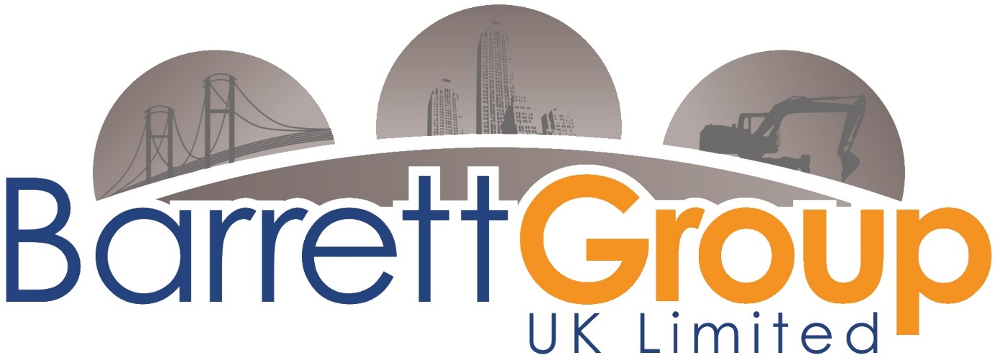

Newsletter

December 2023



**Contents**

**Our Sites** 3

**Our safe working programmes** 8

**Celebrations** 9

**Health and Wellbeing** 10

10

**Working with our clients** 12

**Taking Care over the holiday period** 13

**Summary** 14

# **Our Sites**

Wyre Beach

Project Manager Kris, is working well to achieve great results for our client Balfour Beatty. Coastal works have many challenges, not least is the weather, but our lads are wrapped up in great quality waterproof gear and Kris looks after everyone.

Work is to programme and great progress is being made in constructing the emergency vehicle access ramps.

Key Facts

Job: Wyre Beach Phase 2

Client: Wyre Council

Principal Contractor: Balfour Beatty

Overall Project Value: £35.6 million

Barrett’s Contract Value: £5.5million.

Scope of works: Construct 36 groin cross over ramps and associated tie-ins. Also, stairs and vehicular access points.

Project Completion: April 2026

* A logistically challenging project, working on the beach below the high tide line. On days with short tidal windows, the team pre excavate clay and replace with sand to speed up the process next time they have access.
* Localised dams are formed to slow down the encroaching tide and take the energy out of the waves.  Steel formwork must be used as traditional timber formwork would be destroyed by the sea.
* Work is undertaken in all weather conditions and in the dark to maximise working time on the beach; nothing stops work apart from the Irish sea.  The team must keep an eye on the tide as if they get their timings wrong, equipment could become stranded on the beach with no way off with the tide rising.
* Concrete is transported from the site compound in 9t cabbed dumpers, the furthest pour is 1.2km from the compound.
* Since the beach is open to the public, equipment is escorted using ATV’s driven by designated beach marshals.
* The excavators are fitted with the latest marine specification Leica GPS system. At present we are trialling an AI based human form recognising system, this is attached to all of our plant; it warns the operator of the presence of anyone who enters their blind spot.
* Our equipment is meticulously maintained as there are no second chances with the sea.  Although our operatives are trained to recover stricken equipment in the event of a mechanical failure.
* The project is managed by our Project Manager and Civil Engineer Kris, he has over 25 years’ experience of delivering challenging projects in extreme environments both in the UK and internationally.
* Kris is supported by a team of joiners, plant operators, concrete finishers, and ground workers on site.
* Our Head office team in Flixborough, Scunthorpe support the project through procurement, planning, commercial and HSEQ Management.

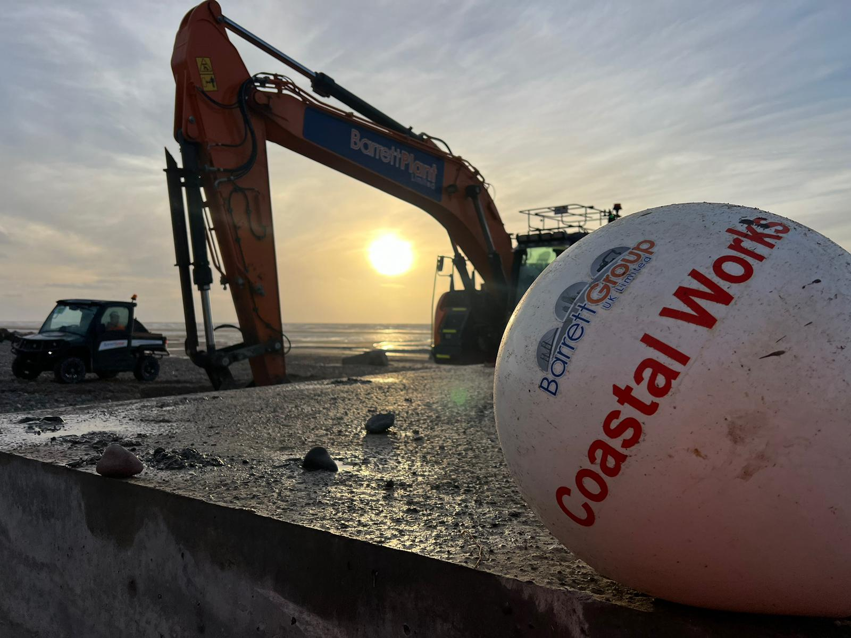

Carol Green – HS2 Balfour Beatty Vinci

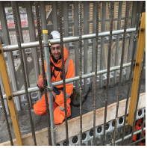Project manager Eamon Barrett heads this project with a great team behind him. Working with our client Balfour Beatty Vinci, we are undertaking the construction of a bridge crossing over a live network rail line.



Excellent standards of lay down presented.

One of our highly skilled steel fixers, behind bars for the day.



The above picture showing the travelling gantry system that allows formwork to be repositioned whilst being slung by the gantry system. This saves time and money for the project and is a great success.

Our teams are producing outstanding works in a challenging environment whilst also being outstanding with safety practice, endorsed by our client Balfour Beatty Vinci.

Curzon Street – HS2 Balfour Beatty Vinci

Our seasoned project manager, Declan Barrett, has led the project from day one, and continues to provide guidance to our great site teams to produce outstanding results for our client. Our newest member of the Barrett team Kieran Kelly will be taking the reigns in December, whilst Declan moves on to our newest project Caldew Bridge, in the Carlisle area.

Being a highly respected main contractor, Barrett Civil Engineering continue to support works to a high standard. We are also very good at bringing innovation to the project when required and continually support the BBV project team.

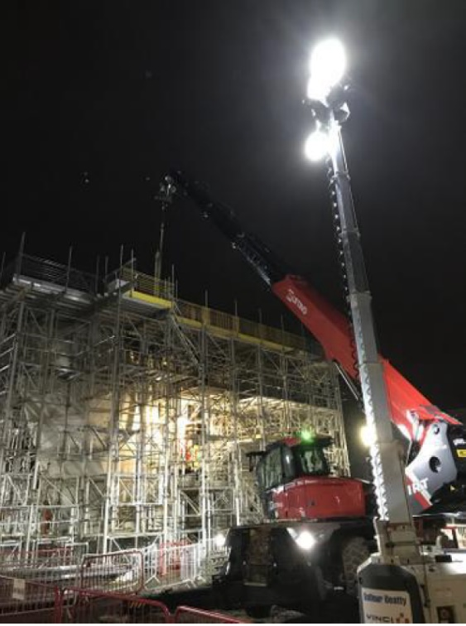

**Pier 16** stripped and ready for the next stage. Barrett team worked hard to produce a quality product and we are proud of the result.

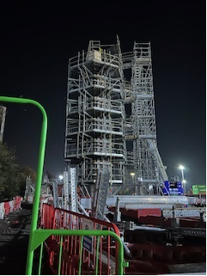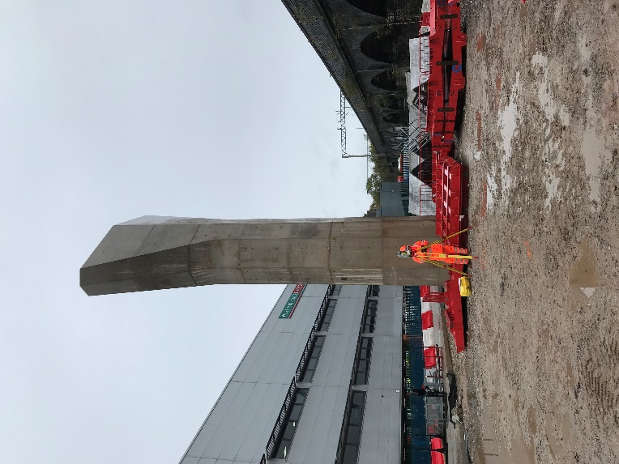

**Pier 17** looking great with our team working well.

Drawing depicting side elevation of pier 15, showing the true size in relation to the working platform staircase.

Nights works undertaken in December. Our site team installing the decking system to large **pier 15** in preparation for formwork and eventual concrete pour.

Lifting practice was undertaken with great skill and accuracy.

**Caldew Bridge – Galliford Try**

The project, a bridge over the river Caldew will be starting December 2023 with a planned completion in March 2024.

The project will be for our returning client Galliford Try.

The structure in red depicts the bridge over the river Calder, whilst also going over the network rail live line.

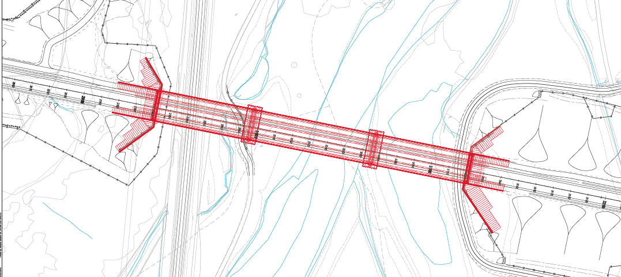

# **Our safe working programmes**

Barret Group Ltd do nothing easy, we care about our workforce and our pledge is to look after our greatest asset.

Our commitment;

Arrive safe, go home safe

Providing our greatest asset with all of the resources needed to stay healthy and safe whilst at work.

People – Our greatest Asset

Competent with continual development.

Performance

Creating a culture of get it right first time where quality outcome is the norm.

Our continued commitment is to develop and train our workforce, to assist with understanding the safest process for getting work done.

Our Project Managers work hard to produce the very best risk assessments and method statements, taking into consideration the hazards involved in undertaking the work. We do however require the assistance of everyone involved in the construction process. Being involved means not going forward if the situation does not look or feel right. Speaking to line management about concerns and having a discussion to ensure all is fine.

The continual involvement of everyone will greatly reduce the likelihood/potential of something going wrong causing an incident or accident, neither of which we want.

Think of our work area as a shop window, our client looks everyday to see how our window looks, if it looks safe and tidy, they are more likely to be happy with progress. If on the other hand they see an unsafe work area, with little or no care

# **Celebrations**

Well done to our site team at HS2 Carol Green, for undertaking a superb rescue drill. As can be seen by the below; produced by our very own Indur Maharjan, the drill was very successful.

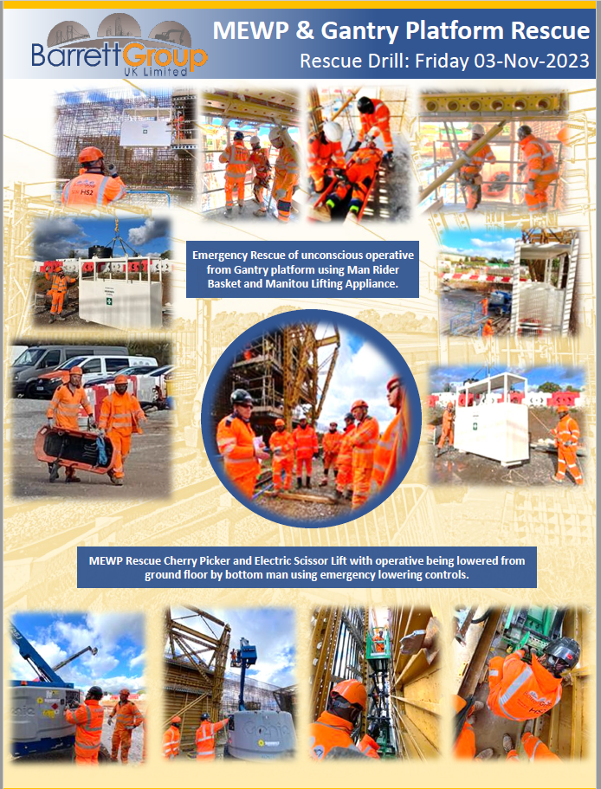

# **Health and Wellbeing**

# 

**Grease is the word.**

**How do you keep BGL machines working day in and day out, it’s all about maintenance.**



**One aspect of maintenance is to regularly grease all those important grease points around the machine.**

**Pros**

* **Keeps the machine running smoothly**
* **Less likely to breakdown**
* **Better and safer control**
* **Quality outcome**
* **More money for future development**
* **CRS retain client confidence and satisfaction**

**Cons**

* **Machine does not run smoothly**
* **More likely to break down**
* **Less control, decreased safety**
* **Poor outcome**
* **Expensive repair costs to CRS**
* **Less Investment Money**
* **CRS lose client confidence**

**Where to find the information to maintain machines.**

**Manufacturers handbooks.**

**Maintenance schedules.**

**Ask your site manager for more details.**

# **Working with our clients**

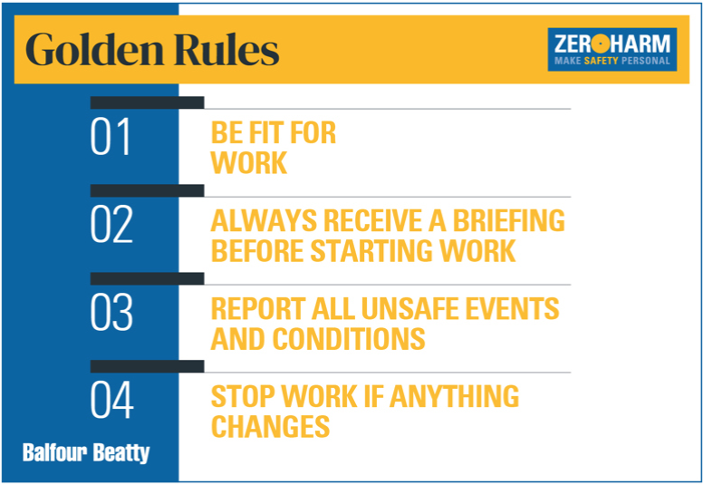

# **Taking Care over the holiday period**

It is very important that we all look after ourselves and others around us.

Use the calculator below to ensure you are safe to drive after consuming alcohol.

[The Morning After Calculator - The Morning After | When will you be safe to drive? (morning-after.org.uk)](https://morning-after.org.uk/drink-drive-calculator/)

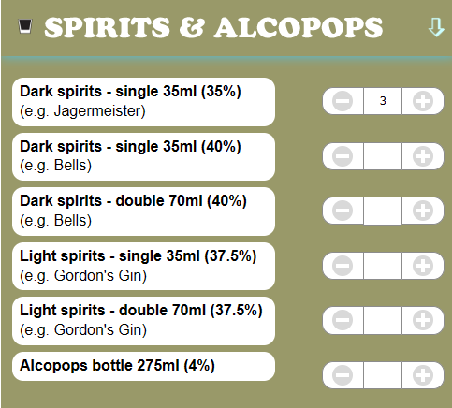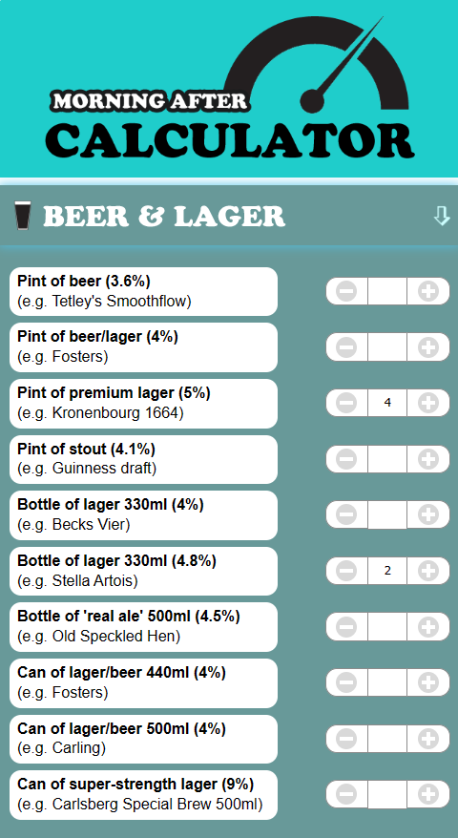 Example

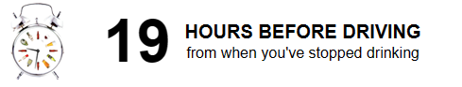

# **Summary**

We have performed well over November and so far through December.

Hours worked so far this year

134,330

Hours to date without incident/accident

25,770

Working together, we can bring hours without incident higher until we gain the full year without incident, what do you think, is this possible?

Together Everyone Achieves More

## HSE data.

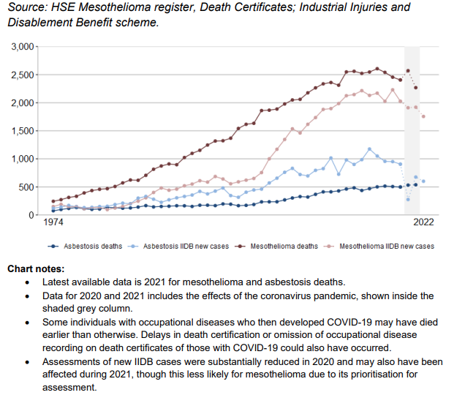

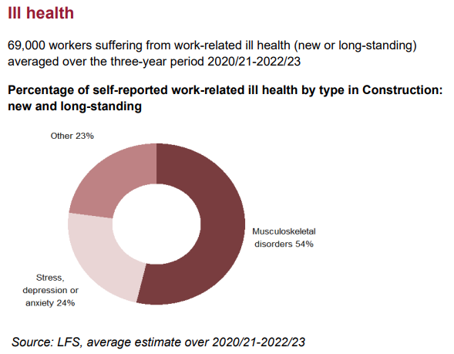

Thank you to all for your efforts and remember that safety is BGL primary goal.

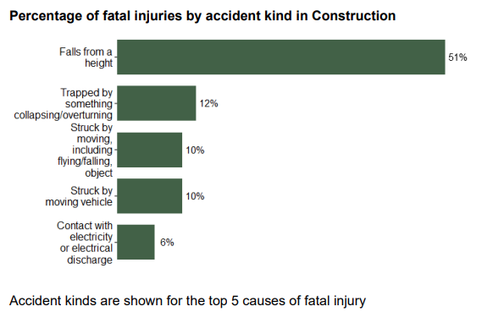

**Arrive safe, go home safe** – Following our RAMS & TBS

**People – Our greatest Asset**, well trained and looked after.

**Performance** – Giving our clients the very best quality outcome

**Don’t Walk By** – **Speak Up** – **Stop/Think - Ask** is this the best way, if it does not feel right, it probably isn’t.

